Assignment: 8

Name: Archie Shah Branch: IT/V Roll No.: 117 Date:26/08/2023

**Aim:** To build an image for sample web application using Dockerfile.

**LO mapped:** LO1, LO5

**Theory:**

The steps to build an image for sample web application using Dockerfile are as follows:

1. **Install Docker**: Ensure that Docker is installed on your system. You can download and install it from the [Docker website](https://www.docker.com/get-started).

|  |
| --- |
|  |

1. **Create a Project Directory**: Start by creating a directory for your project. Inside this directory, you will place your web application code and Dockerfile.

|  |
| --- |
|  |

1. **Write a Dockerfile**: Create a Dockerfile in your project directory. This file contains instructions for building the Docker image. Here's a simple example of a Dockerfile for a Node.js web application:

|  |
| --- |
|  |

1. **Place Application Code**: Place your web application code, including HTML, JavaScript, CSS, and any other assets, in the same project directory.

|  |
| --- |
|  |

1. **Build the Docker Image**: Open a terminal and navigate to your project directory. Run the following command to build the Docker image:

|  |
| --- |
|  |

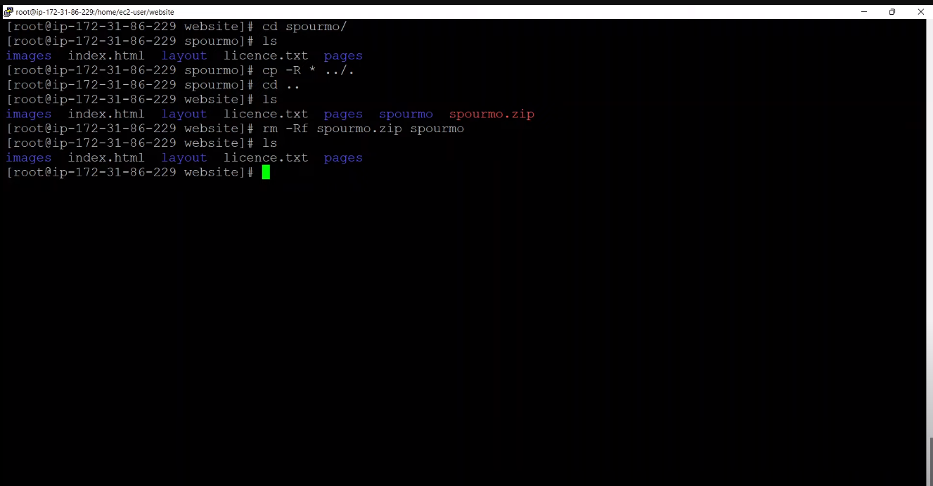

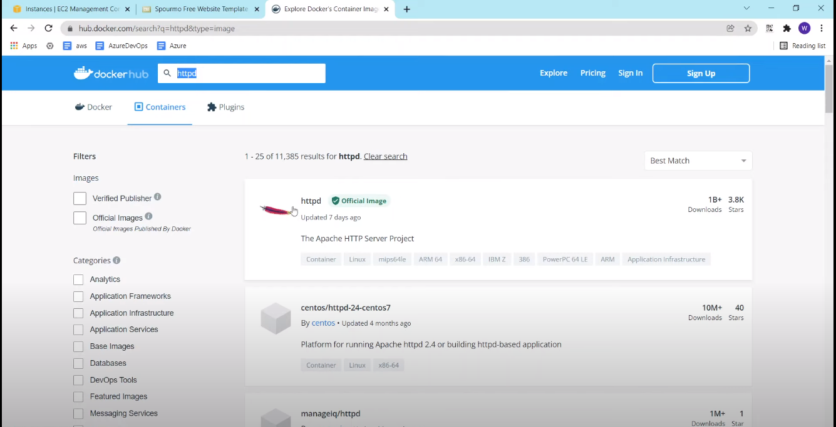

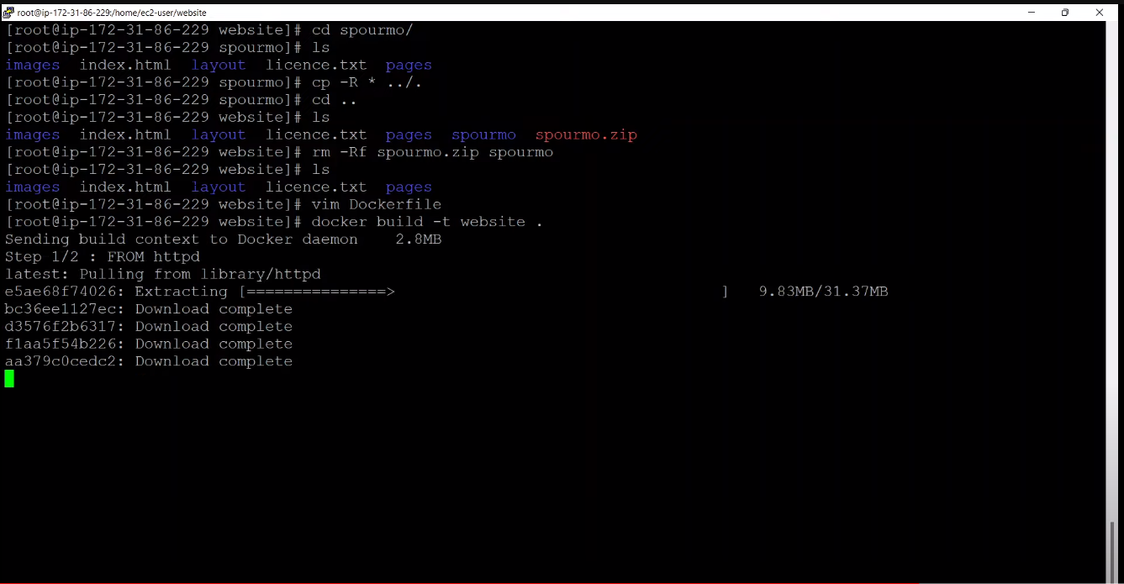

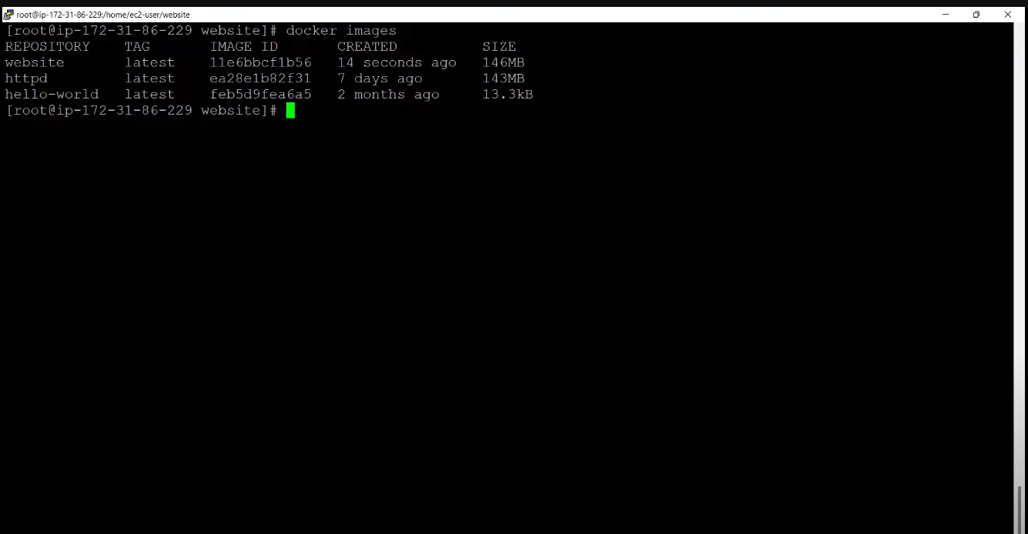

1. **Run a Container**: After successfully building the image, you can run a container based on that image with the following command:

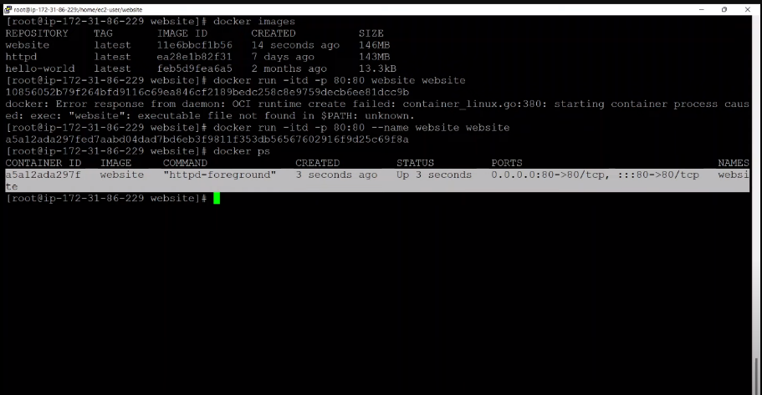

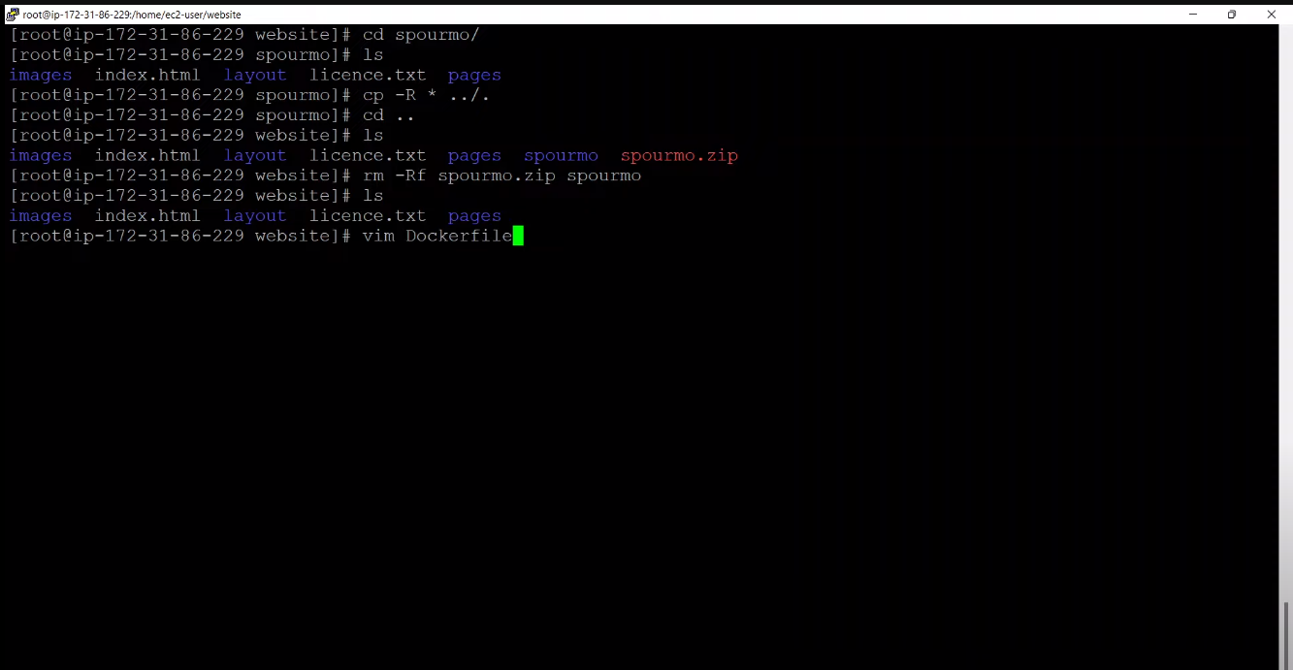

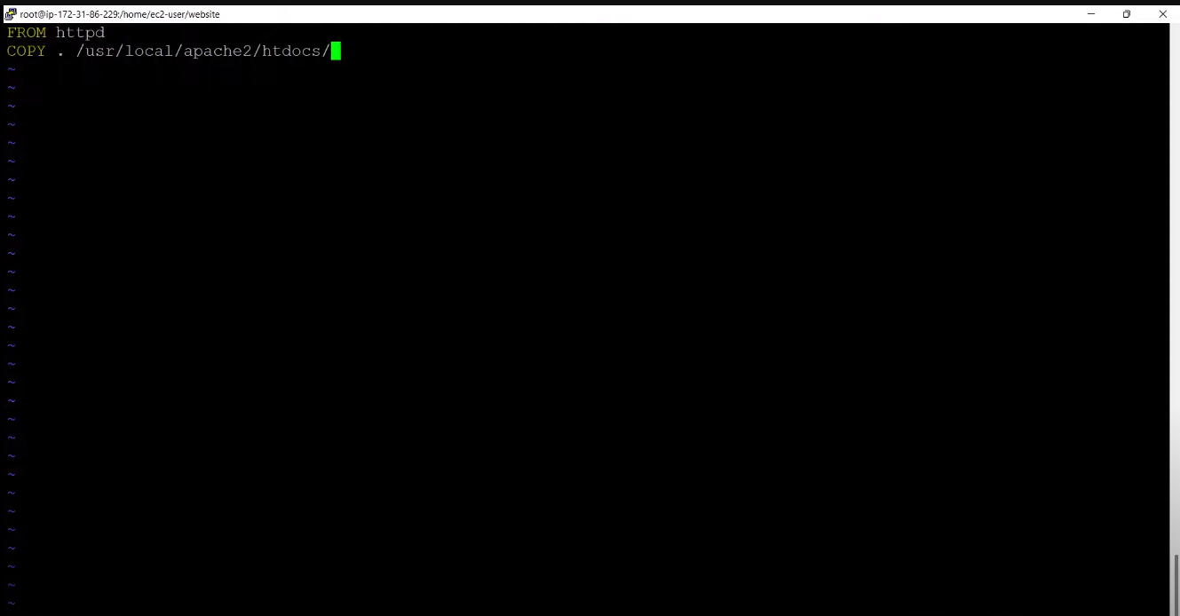

1. **Access Your Web Application**: Open a web browser and navigate to **http://localhost:8080** to access your web application running in the Docker container.

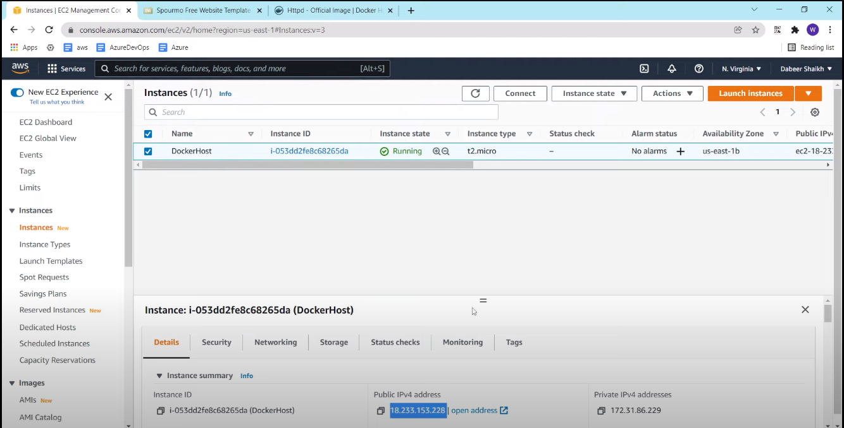

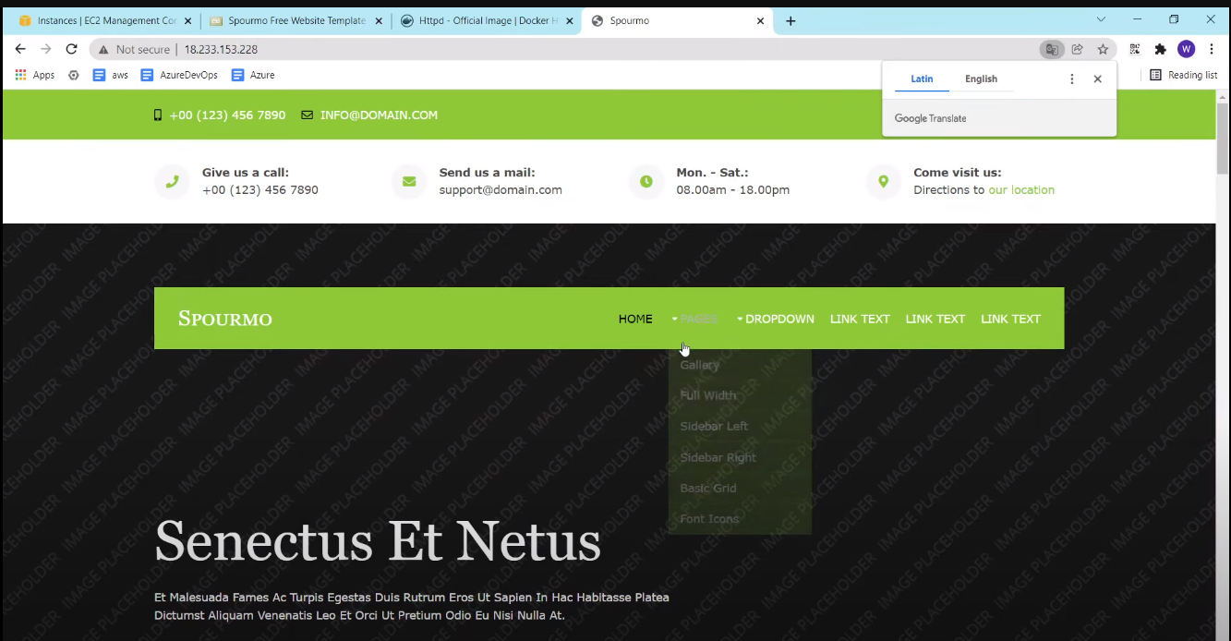

Your web application is now running inside a Docker container. You can further customize your Dockerfile and the application code as needed. Make sure to manage your containers and images appropriately, especially when dealing with production deployments.

**Conclusion:** We conclude by saying that we built a web app using DocerFile.